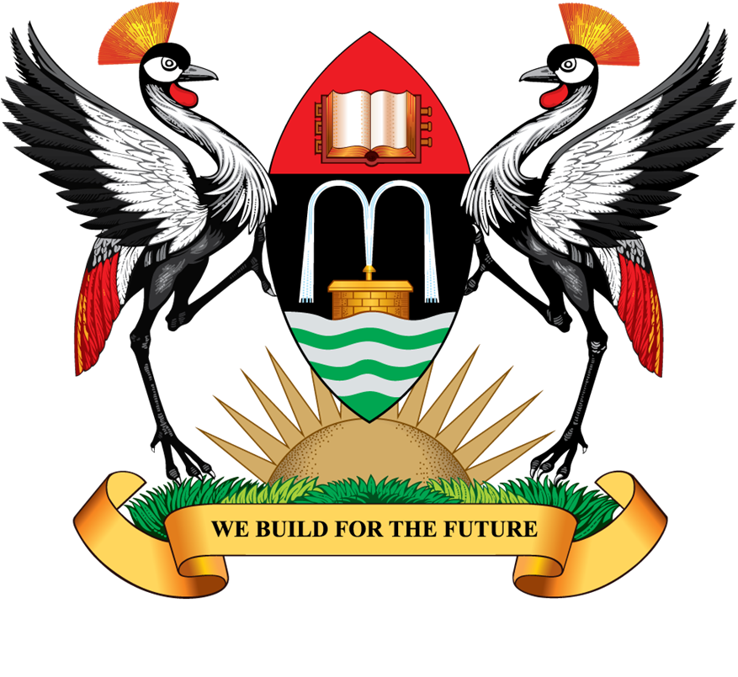

MAKERERE UNIVERSITY

71ST VIRTUAL GRADUATION CEREMONY

The Chancellor will confer degrees and award diplomas to over 11,000 graduands.

(Please take note of the Dates when the respective Colleges are presenting graduands)

DATE: MONDAY, 17TH MAY, 2021
- College of Natural Sciences
- College of Health Sciences
- School of Law

DATE: TUESDAY, 18TH MAY, 2021
- College of Agricultural and Environmental Sciences
- College of Education and External Studies

DATE: WEDNESDAY, 19TH MAY, 2021
- College of Business and Management Sciences
- College of Computing and Information Sciences
- College of Veterinary Medicine, Animal Resources and Bio-security

DATE: THURSDAY, 20TH MAY, 2021
- Makerere University Business School

DATE: FRIDAY, 21ST MAY, 2021
- College of Engineering, Design, Art and Technology
- College of Humanities and Social Sciences

Source: Mak Department of the Academic Registrar, Room 501, Level 5, Senate Building

